Enterprise Data Cleaning and ETL
Orchestration Framework Using Python
Infosys Virtual Internship Project
Project Documentation Report

Submitted By | Himaja, Jagan, Raghul
Internship | Infosys Springboard Virtual Internship
Technology Stack | Python | Apache Airflow | Pandas | PySpark | Streamlit

Milestone 1: Environment Setup & Pipeline Design
Objective
The objective of Milestone 1 is to configure Apache Airflow as the orchestration engine and define the overall ETL pipeline architecture. This includes setting up the development environment, designing the data models, and establishing the extraction pipeline structure.

What We Did
1. Installed and configured Apache Airflow on Ubuntu (WSL2) environment.
2. Designed the overall ETL pipeline architecture with three core stages: Extract, Transform, and Load.
3. Defined the high-level data model using the Literacy Rate dataset sourced from Kaggle.
4. Created and configured Airflow DAGs to orchestrate the ETL pipeline.
5. Set up extraction scripts to read data from CSV sources.
6. Verified the Airflow web interface running on localhost:8080.

Data Model
Column | Data Type | Description
S.No | Integer | Serial Number (Primary Key)
Country | String (VARCHAR) | Name of the Country
Literacy Rate | Float (DECIMAL) | Literacy Rate percentage (0-100)
Year | Integer | Year of recorded literacy data

Languages & Technologies Used
Language | Python 3.9
Orchestration | Apache Airflow 2.x
Environment | Ubuntu (WSL2), VS Code
Data Source | CSV (Kaggle - Literacy Rate Dataset)
Libraries | Pandas, SQLAlchemy, Typing

Output
Apache Airflow was successfully installed and configured. The enterprise_etl_pipeline DAG was created with three tasks: extract_literacy_data, transform_literacy_data, and load_literacy_data. The DAG was scheduled @daily and verified as functioning correctly in the Airflow UI.

Figure 1: Apache Airflow Login Page (localhost:8080)
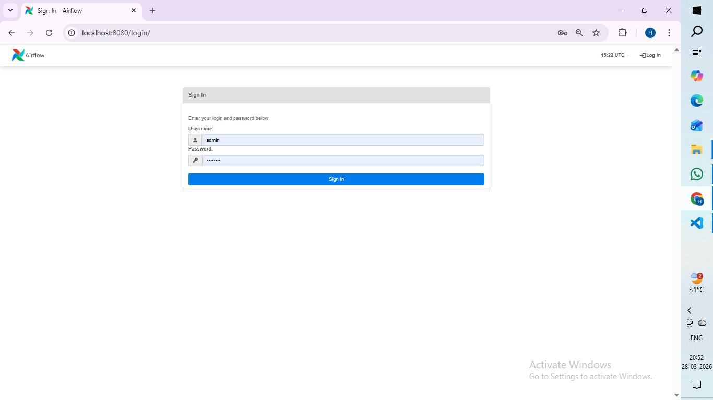
Figure 2: Airflow DAGs List — enterprise_etl_pipeline Active
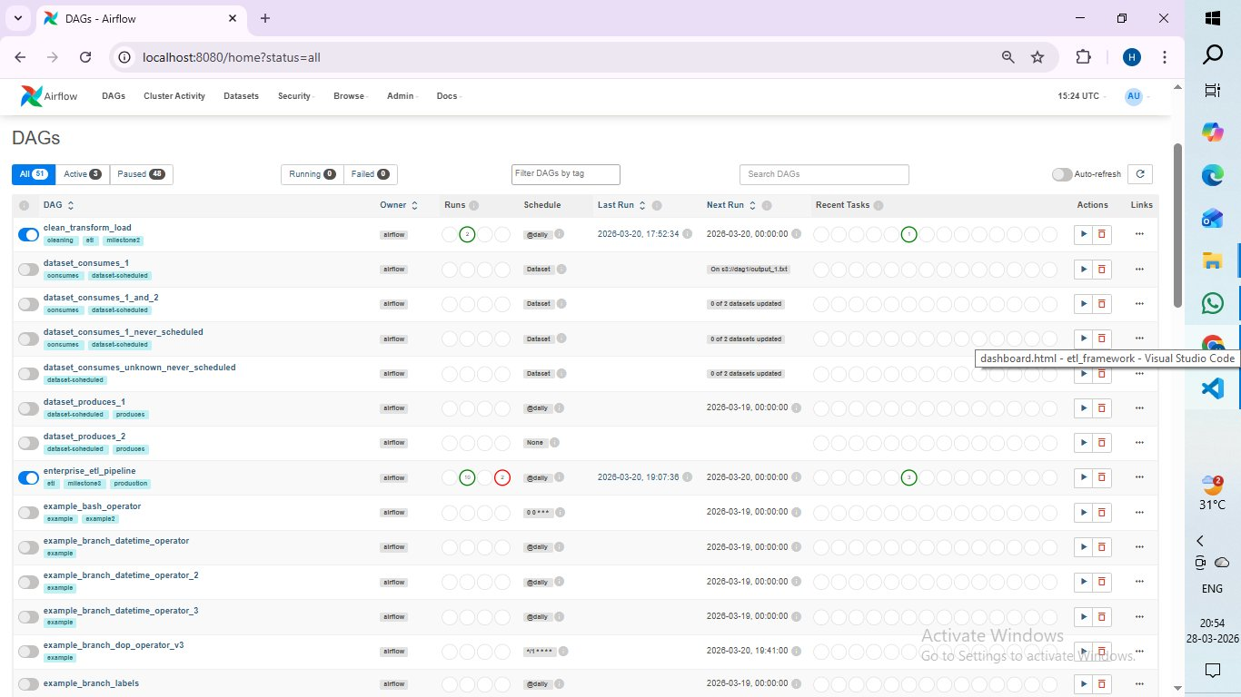
Figure 3: enterprise_etl_pipeline DAG Graph — Extract → Transform → Load
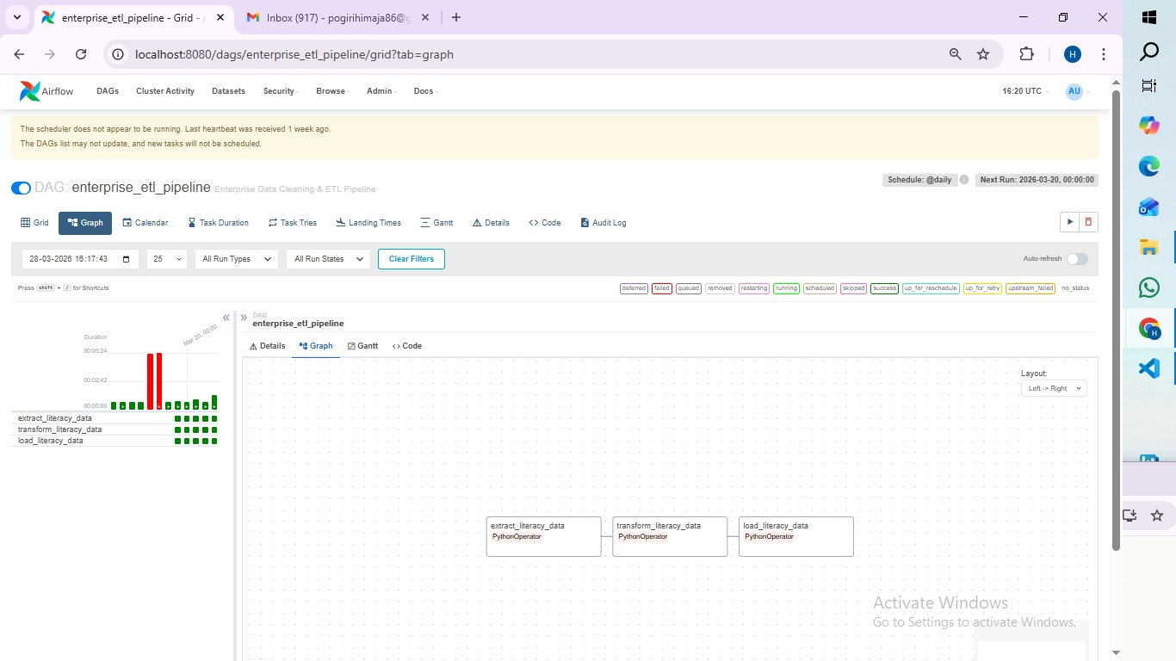

Milestone 2: Data Cleaning & Transformation
Objective
The objective of Milestone 2 is to implement data preparation workflows for the ETL pipeline. This includes cleaning raw data, applying transformation rules, and generating a structured dataset ready for loading into the final data layer.

What We Did
1. Developed a rule-based cleaning engine to apply standard cleaning rules on the raw dataset.
2. Implemented data transformations using the Python Pandas library.
3. Applied six cleaning rules: column standardization, duplicate removal, missing value handling, whitespace removal, data type conversion, and data validation.
4. Generated a cleaned dataset saved to data/processed/literacy_cleaned.csv.
5. Tested the cleaning pipeline using unit tests.

Data Cleaning Rules Implemented
Rule 1 | Standardizing Column Names — Converted to lowercase with underscores
Rule 2 | Removing Duplicate Records — Eliminated repeated data entries
Rule 3 | Handling Missing Values — Removed rows with null/missing values
Rule 4 | Removing Extra Spaces — Stripped whitespace from text fields
Rule 5 | Data Type Conversion — Converted literacy rate column to numeric format
Rule 6 | Data Validation — Validated literacy rate values within range 0-100

Languages & Technologies Used
Language | Python 3.9
Data Processing | Pandas
Orchestration | Apache Airflow
Testing | Pytest
Environment | Ubuntu (WSL2), VS Code

Output
The clean_transform_load DAG was successfully executed with 2 total runs, both achieving Total Success status. Mean run duration: 51 seconds. The cleaned dataset was saved to the processed data layer.

Figure 4: clean_transform_load DAG — Run Summary (Total Success: 2)
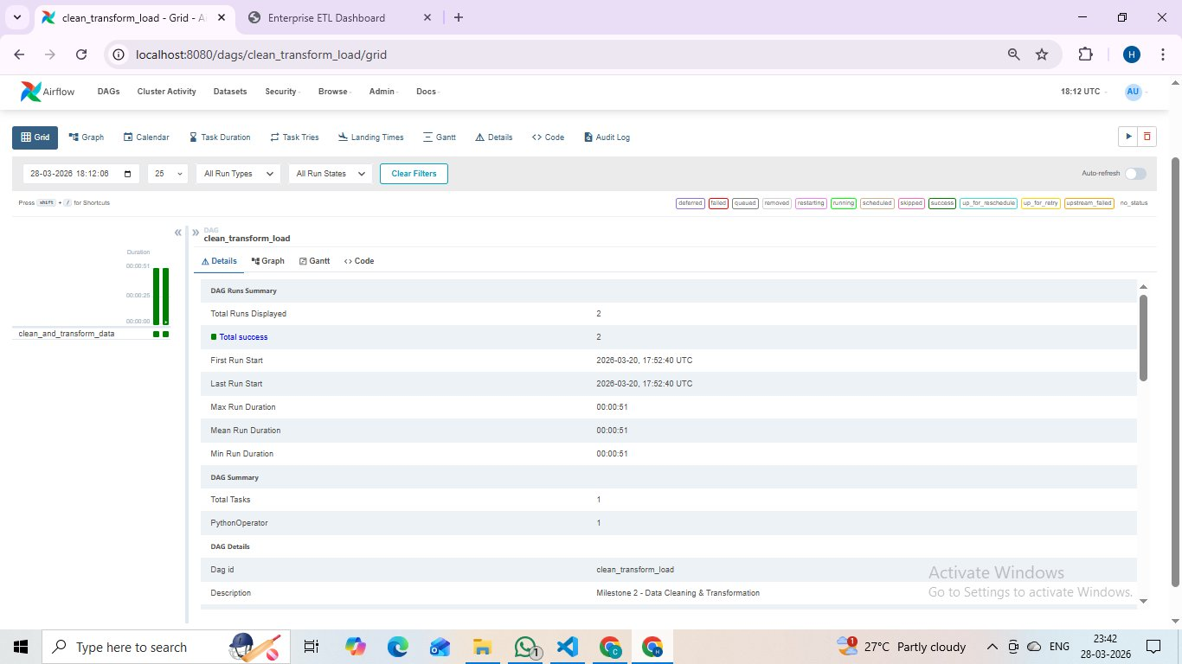
Figure 5: clean_transform_load DAG Graph — clean_and_transform_data Task
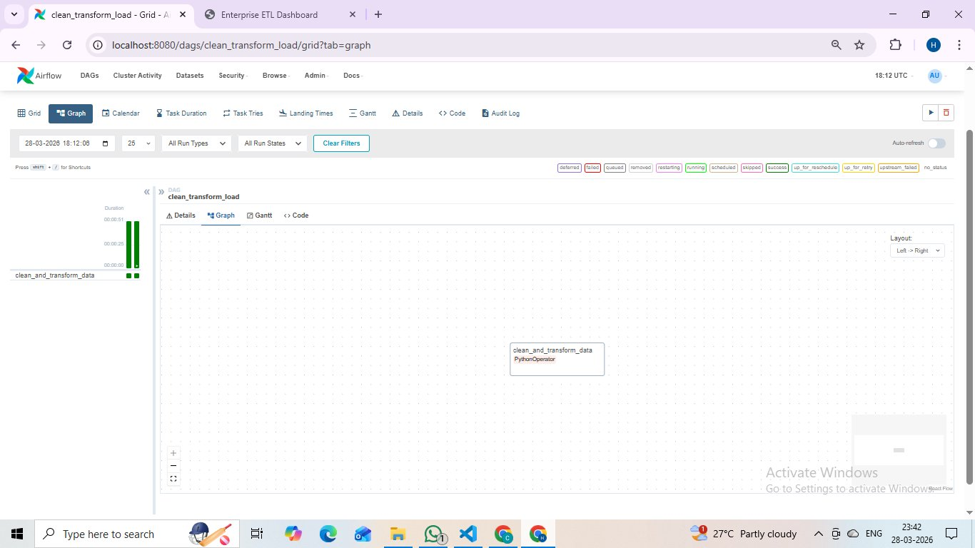

Milestone 3: Orchestration & Monitoring
Objective
The objective of Milestone 3 is to add Airflow DAGs for orchestration and integrate monitoring tools into the ETL pipeline. This includes configuring DAG scheduling, adding centralized logging, and integrating alert callbacks.

What We Did
1. Created monitoring_dag with three tasks: pipeline_health_check, generate_report, and send_alert_summary.
2. Configured DAG scheduling with @daily trigger for automated execution.
3. Integrated centralized logging using the PipelineLogger utility module.
4. Implemented on_success_callback and on_failure_callback alert configurations.
5. Verified monitoring DAG with 2 successful runs.

Alert Configuration
on_success_callback | Triggered when pipeline completes successfully
on_failure_callback | Triggered when pipeline encounters an error
SLA Miss Alert | Triggered when pipeline exceeds defined time limit
SMTP Configuration | Configured in airflow.cfg for email notifications

Languages & Technologies Used
Language | Python 3.9
Orchestration | Apache Airflow 2.x
Logging | Python logging module (PipelineLogger)
Alerts | Airflow Callbacks (on_success_callback, on_failure_callback)
Environment | Ubuntu (WSL2), VS Code

Output
The monitoring_dag was successfully executed with 2 total runs, both achieving Total Success status. Three monitoring tasks executed successfully. Mean Run Duration: 1 minute 18 seconds. Alert system verified as operational.

Figure 6: monitoring_dag — Run Summary (Total Success: 2)
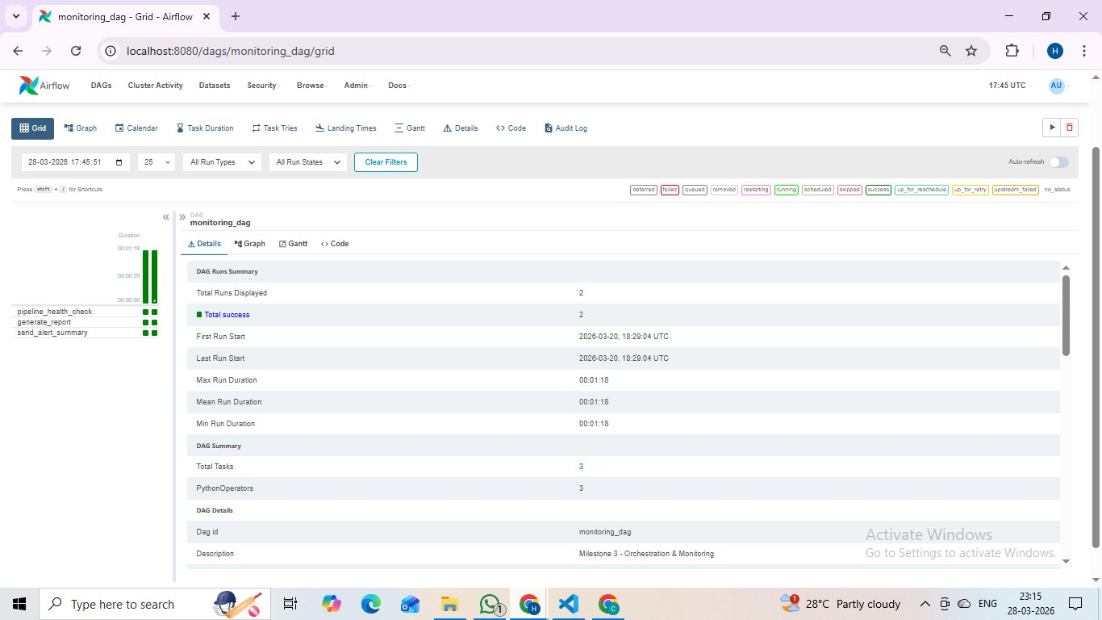
Figure 7: monitoring_dag Graph — pipeline_health_check → generate_report → send_alert_summary
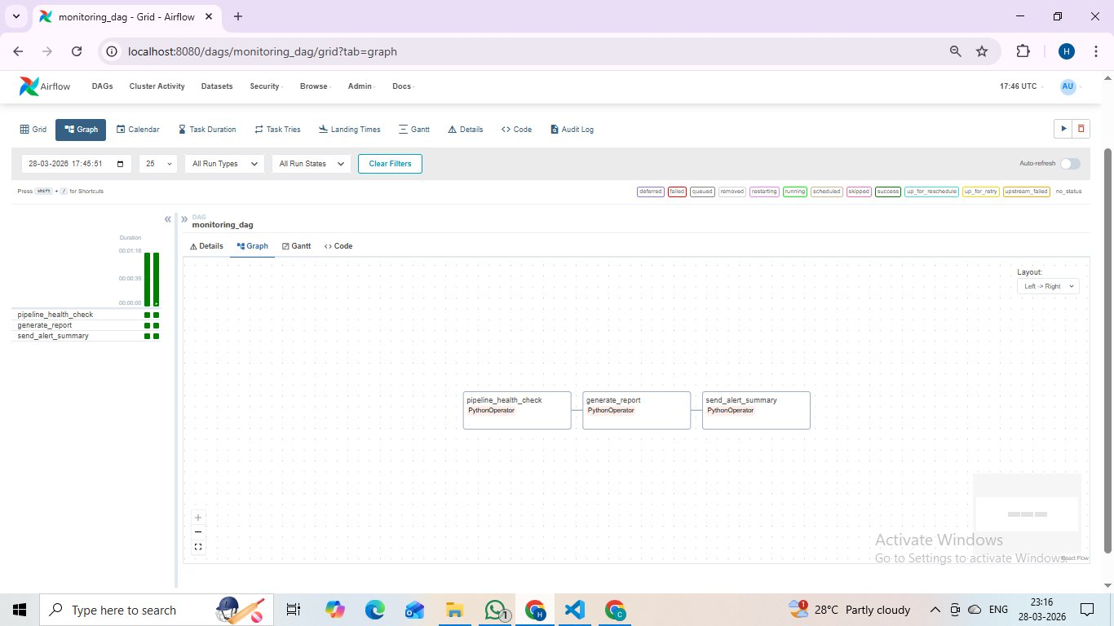

Milestone 4: Dashboards & Deployment
Objective
The objective of Milestone 4 is to build an interactive monitoring dashboard and finalize the deployment of the complete ETL framework. This includes integrating a real-time pipeline dashboard and testing on production-scale datasets.

What We Did
1. Built an Enterprise ETL Pipeline Dashboard with four sections: Overview, Pipeline Status, Data Analysis, and Logs & Alerts.
2. Deployed the dashboard at 127.0.0.1:5500/dashboard.html.
3. Tested the complete ETL pipeline on the Literacy Rate production dataset (10,000 records).
4. Verified all 4 milestones as complete on the dashboard.

Languages & Technologies Used
Language | Python 3.9, HTML, CSS, JavaScript
Dashboard | HTML Dashboard with Chart.js
Orchestration | Apache Airflow 2.x
Visualization | Chart.js (Bar, Donut, Line Charts)
Environment | Ubuntu (WSL2), VS Code, Live Server

Output
The Enterprise ETL Pipeline Dashboard was successfully deployed. All 4 Milestones marked Complete. Overall Success Rate: 90%. Total DAGs: 3. Total Runs: 12. Records processed: 10,000 extracted, ~9,500 after cleaning.

Figure 8: Dashboard Overview — All Milestones Complete, 90% Success Rate
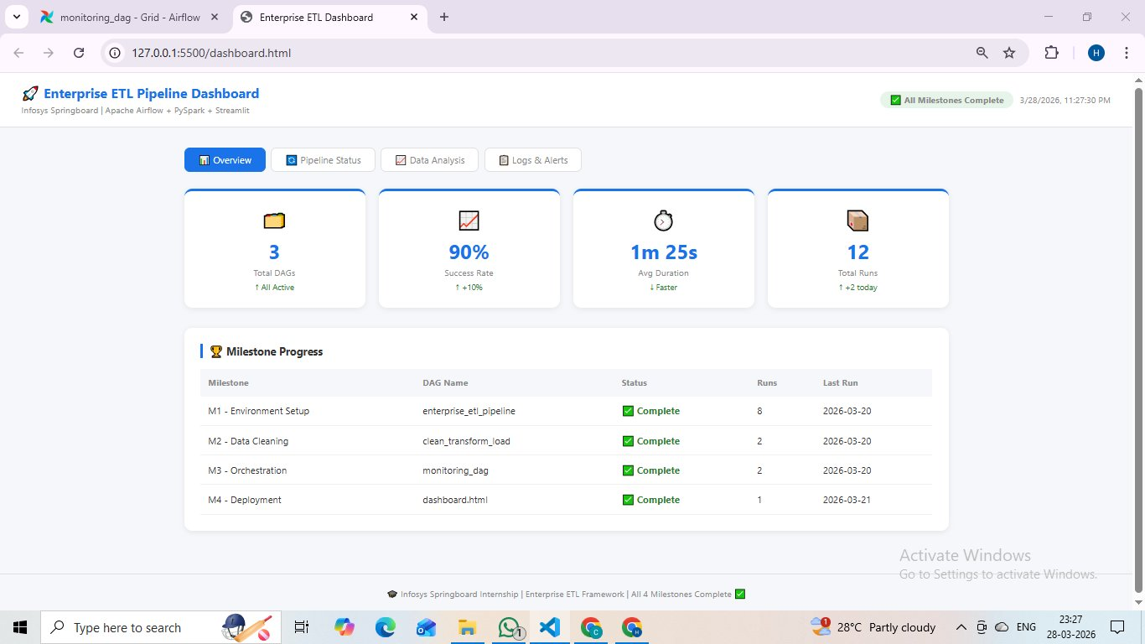
Figure 9: Pipeline Status — DAG Run Results & Overall Success Rate
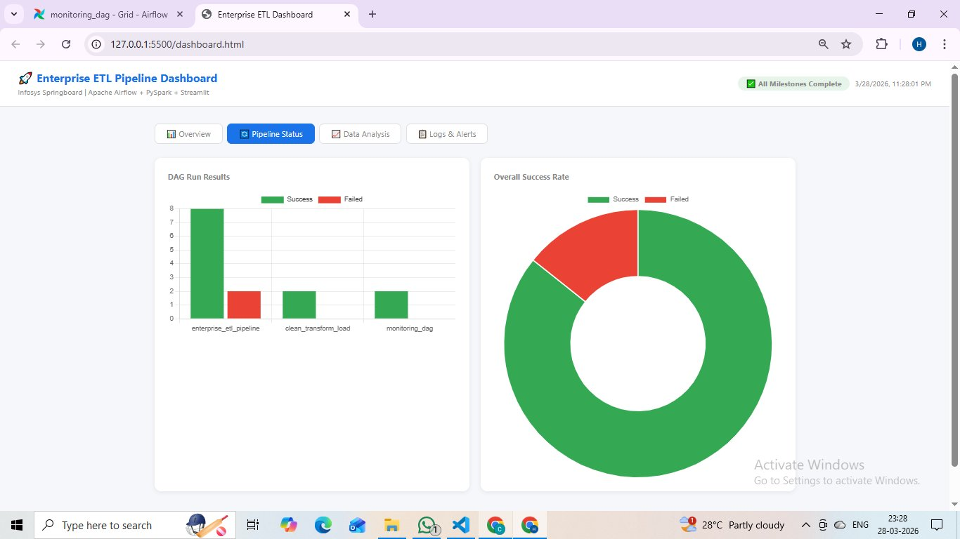
Figure 10: Data Analysis — Records Per Stage & Duration Per Stage
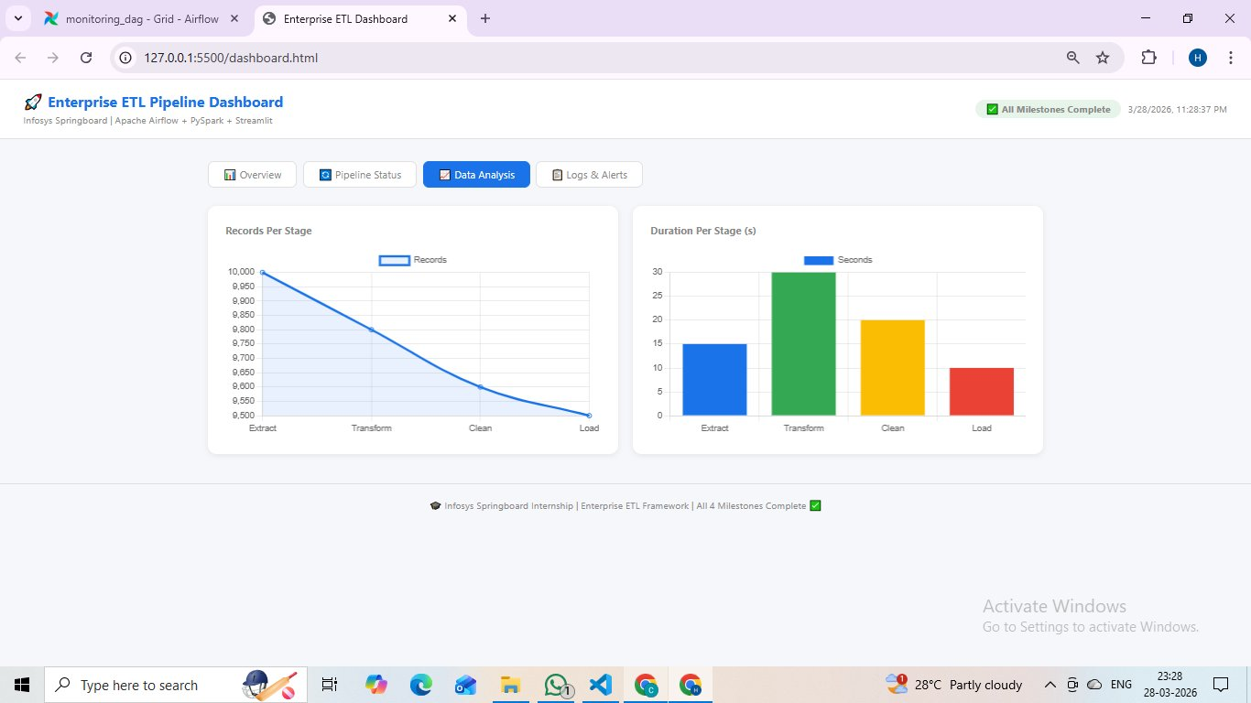
Figure 11: Logs & Alerts — Pipeline Logs & Alert Configuration
